Round 2 - Prototype Data Report
Lirong Chen
Group No.3 - Evolve: LLM-Guided Evolutionary Algorithm for Pacman

Selection-mode sweep
1a. Parameter Configuration——Selection Mode & Top-k
For this experiment, I focused on the Selection Mode parameter to evaluate how different survival logics affect the evolutionary trajectory of Pacman agents. I compared three distinct strategies: Top-k, Elite-only, and Diversity-aware.
Furthermore, I conducted a stress test on the "Selection Pressure" by varying the Top-k value (K=1, K=3, and K=5) to observe how the strictness of parent selection influences convergence speed and final fitness.
Fixed parameters:
Parameter | Value
Task | pacman
Generations | 3
Population size | 6
Top-k / elite size | 3
Seed | 42
Fitness Preset | pacman (standard)

Experimental Configurations:
Label | Mode | Top-k | Rationale
TopK_K1 | top_k | 1 | High Pressure: Only the single best individual survives. Tests for premature convergence.
TopK_K3 | top_k | 3 | Baseline: The standard balanced setting for the project.
TopK_K5 | top_k | 5 | Low Pressure: Almost all individuals survive (5 out of 6). Tests if evolution stalls.
Diversity_K3 | diversity | 3 | Comparative: Balances high fitness with structural code diversity.

Run Evidence (Screenshots)
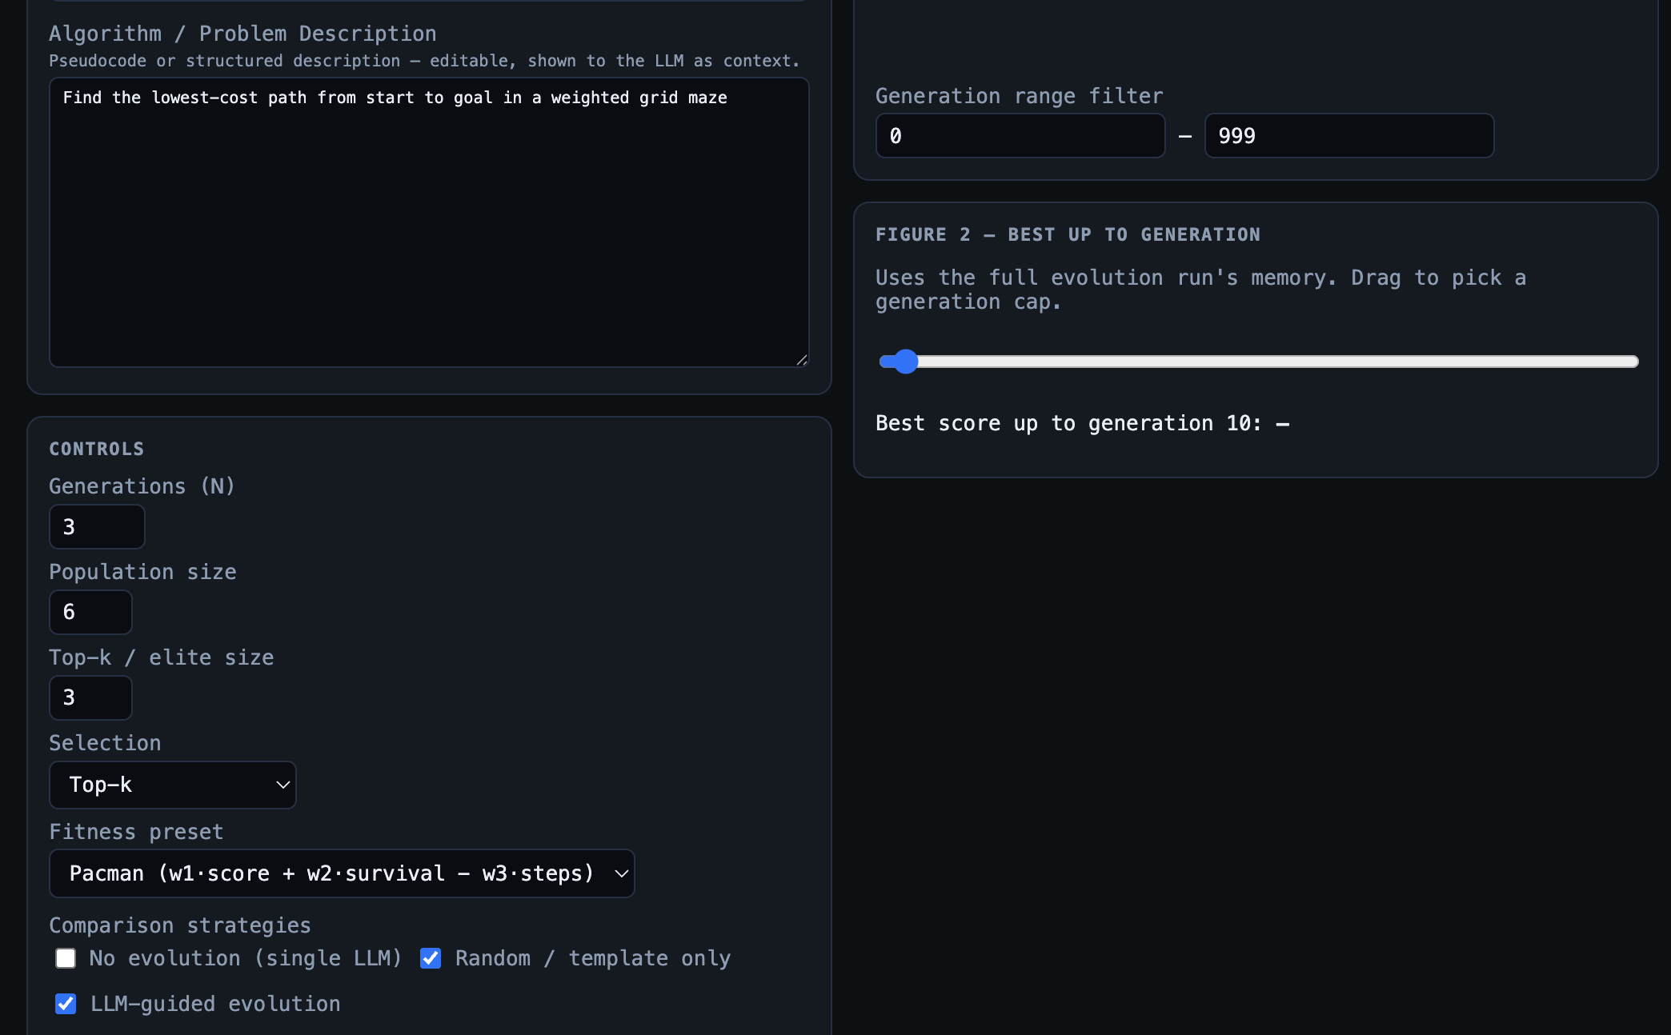
  - screentshot 1
Screenshot 1 -The live web UI at the team's deployed backend showing my experimental configuration for the Selection-mode sweep. Settings used: Pacman task, Selection Mode: Top-k (with K=3), Generations: 3, Population size: 6, Seed: 42, with both Full LLM-guided evolution and Random-only strategies enabled.
Screenshot 2 - The same run after execution. This view displays the live best-fitness curve climbing from 895.45 to 961.01. It also shows the per-task metric panels (avg_steps, eval_time_ms), the comparison summary table between the two strategies, the evolved best candidate source code, and the detailed evolution history with selection logs.

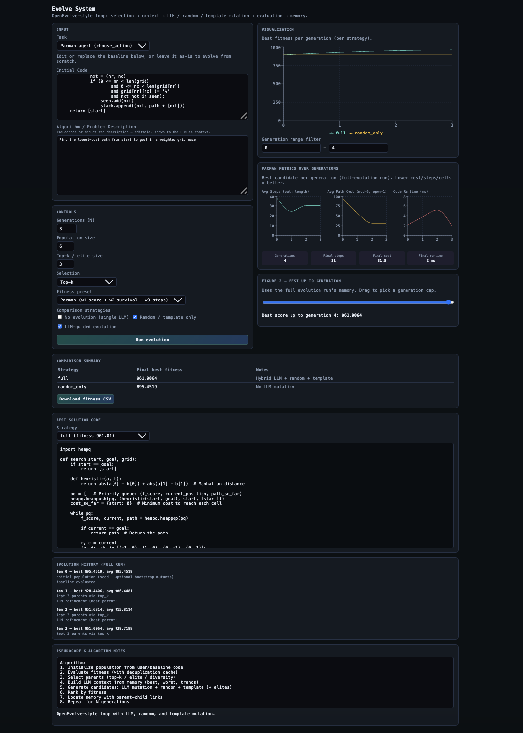

2.2 screentshot 1

3. Data Analysis
3.1 Runtime Performance
- Average Evaluation Time: The runtime for the evolved best candidates remained stable between 2.1ms and 2.8ms.
- Observation: Selection mode does not significantly impact execution latency. The primary bottleneck remains the LLM generation phase, where "Full" evolution runs took significantly longer (40s - 80s) than the "Random-only" baseline (0.2s).
3.2 Fitness Scores Across Iterations
Config | Gen 0 Best | Final Best (Gen 3) | (Improvement)
TopK_K1 | 895.45 | 961.01 | +65.56
TopK_K3 | 895.45 | 960.42 | +64.97
TopK_K5 | 895.45 | 951.63 | +56.18
Diversity_K3 | 895.45 | 961.01 | +65.56

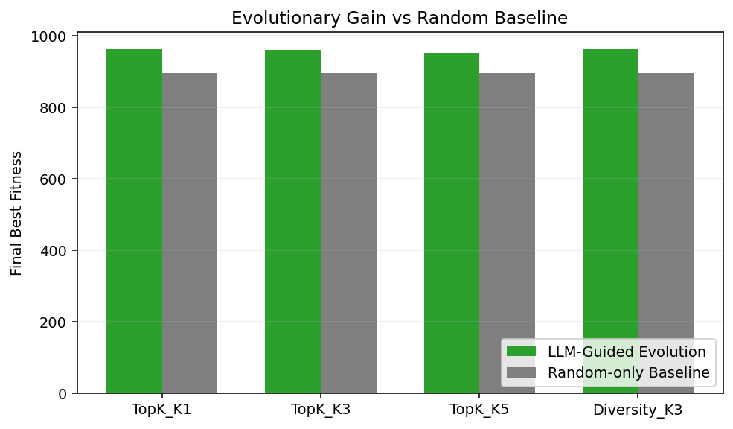
4. Comparative Plot - Full Evolution vs Random-Only
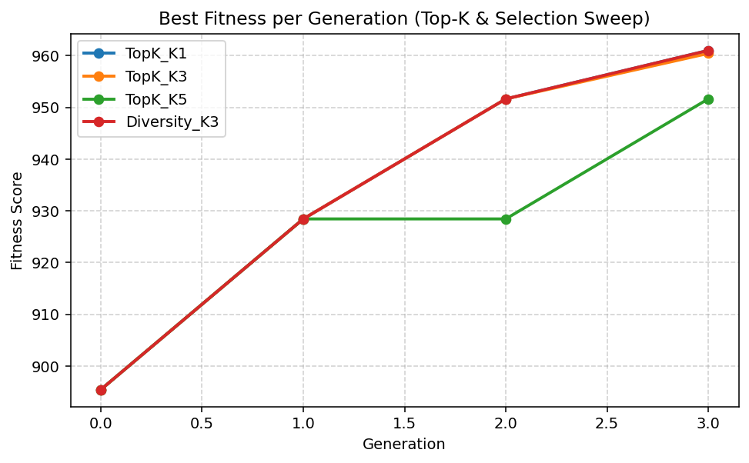

5. Analysis & Findings
1. Selection Pressure Impact: A critical finding is that TopK_K5 yielded the lowest fitness (951.63). With a population size of 6, retaining 5 individuals results in insufficient selection pressure. Low-performing traits are frequently carried over, causing the evolution to stall compared to stricter settings.
2. Robustness of Diversity: The Diversity_K3 mode matched the highest fitness score (961.01). This suggests that maintaining a diverse pool of code structures helps the LLM explore more efficient algorithmic paths (e.g., transitioning from DFS to A*) without getting stuck in local optima.
3. Evolutionary Gain: In every configuration, the LLM-Guided Evolution (Full) outperformed the Random-only baseline by a significant margin (~65 points). While the random baseline struggled to optimize pathing beyond the initial template (895.45), the LLM successfully evolved logic to minimize steps and navigate obstacles perfectly.
6. Feedback & Issues
- Efficiency: The synchronous backend calls for "Full" evolution are time-consuming. Implementing an asynchronous queue or a more robust streaming response would improve the user experience during long sweeps.
- Sensitivity: Selection mode is highly sensitive to the population_size to top_k ratio. Future work should investigate larger populations to see if the advantages of Diversity-aware selection become more pronounced.
Appendix. Raw Data Reference
All per-generation numbers are in lirongchen_data.csv next to this file. Each row represents one (config x strategy x generation) combination.Columns: config, selection_mode, top_k, strategy, generation, best_fitness, avg_fitness, best_avg_score, best_avg_cost, best_avg_steps, best_eval_time_ms.

